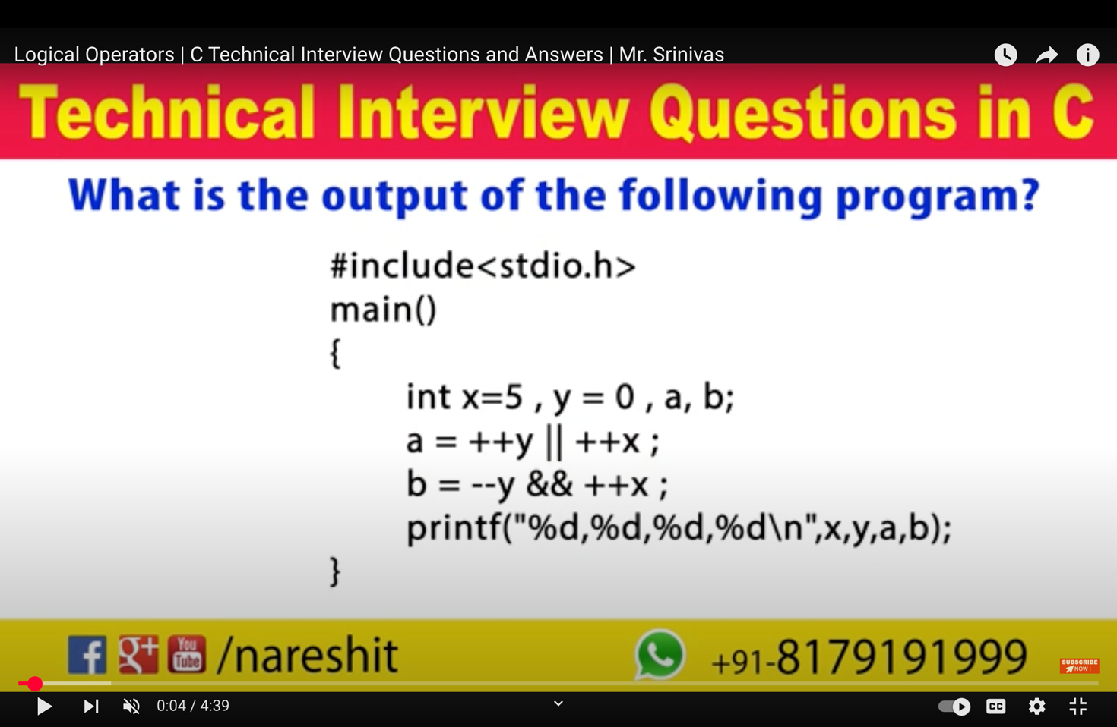

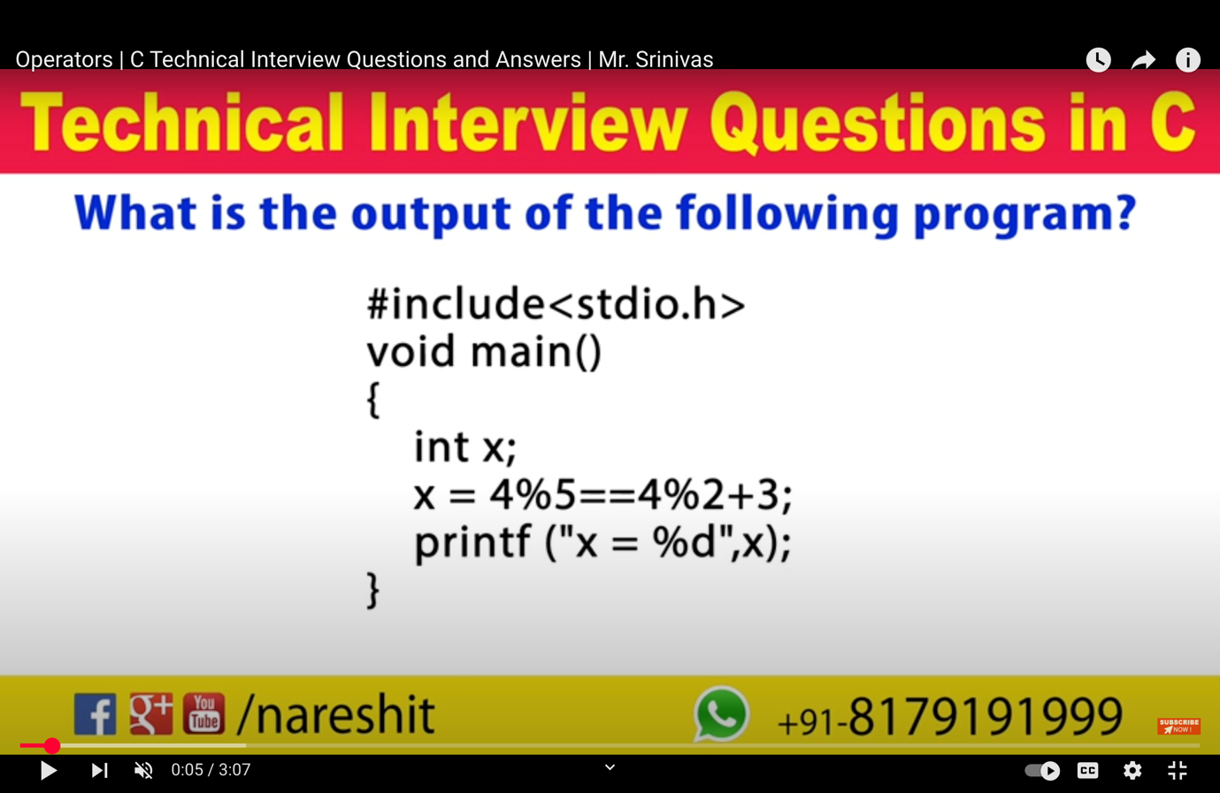

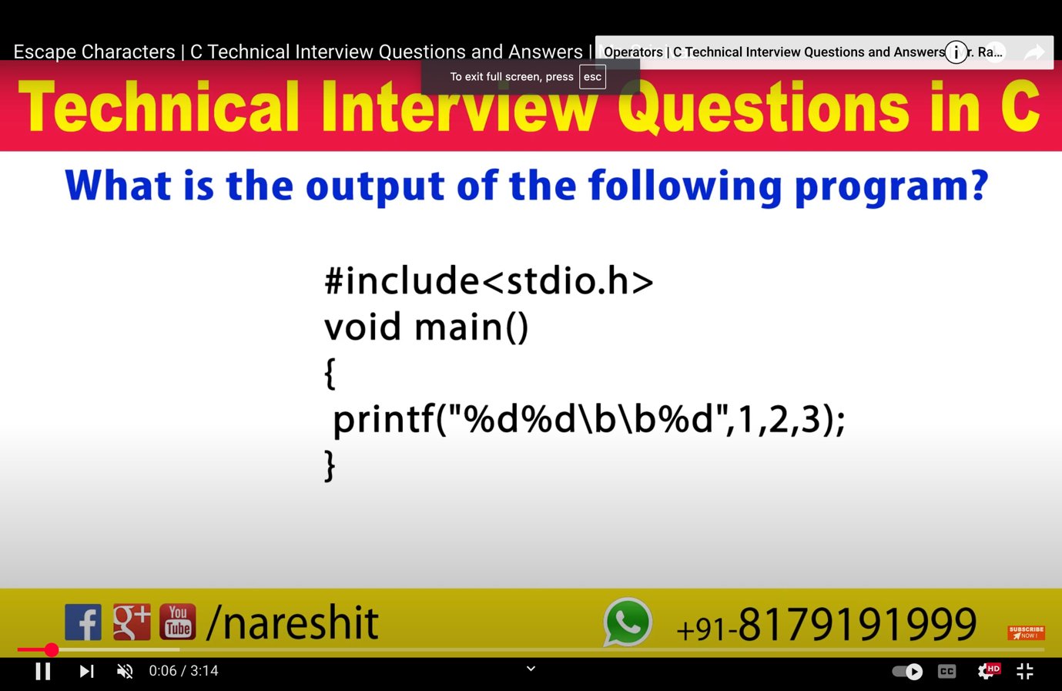

doubt

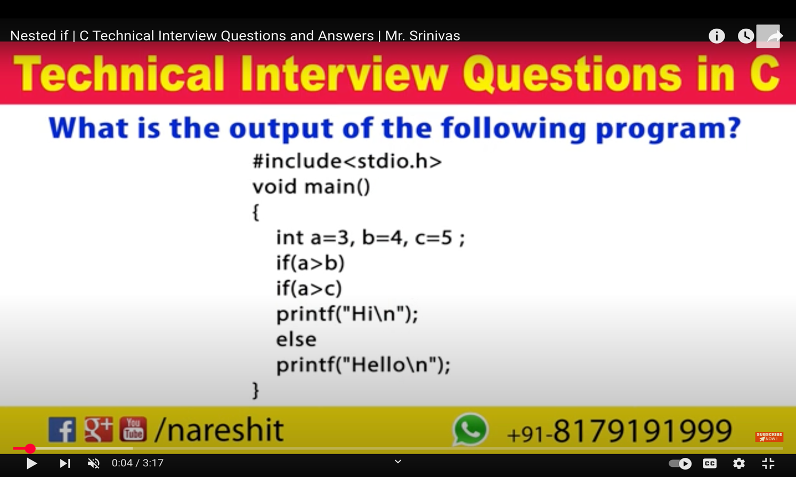

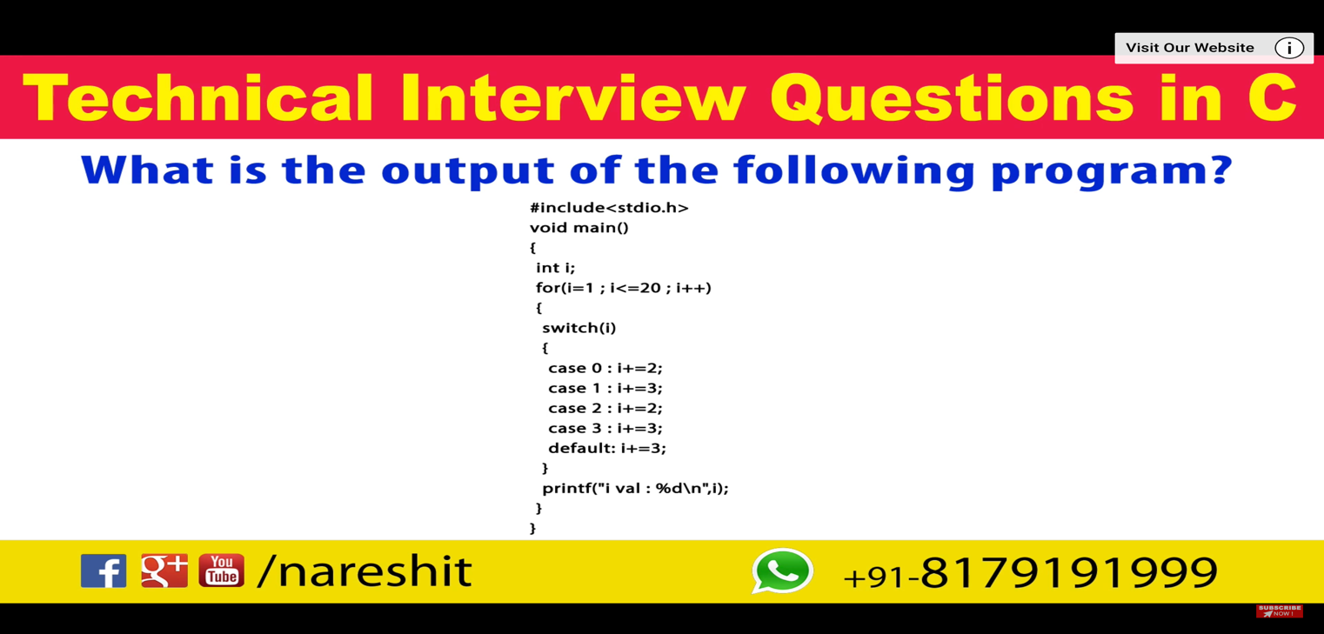

jh

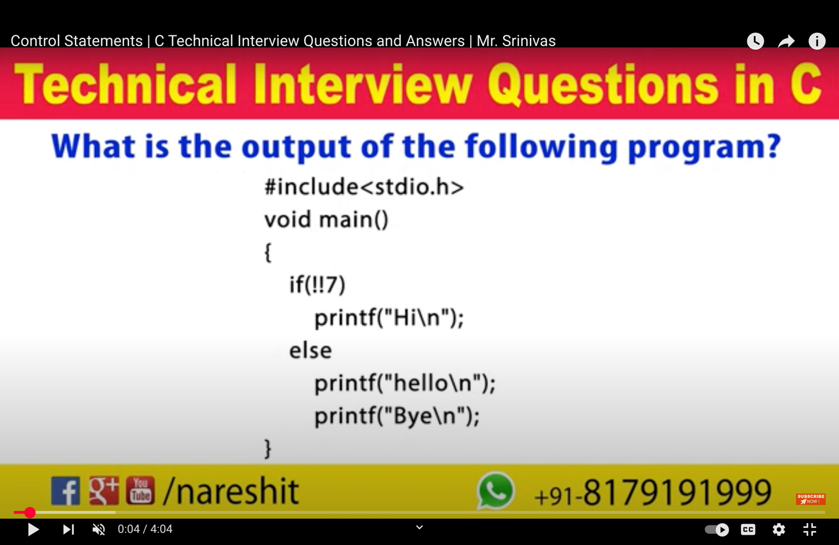

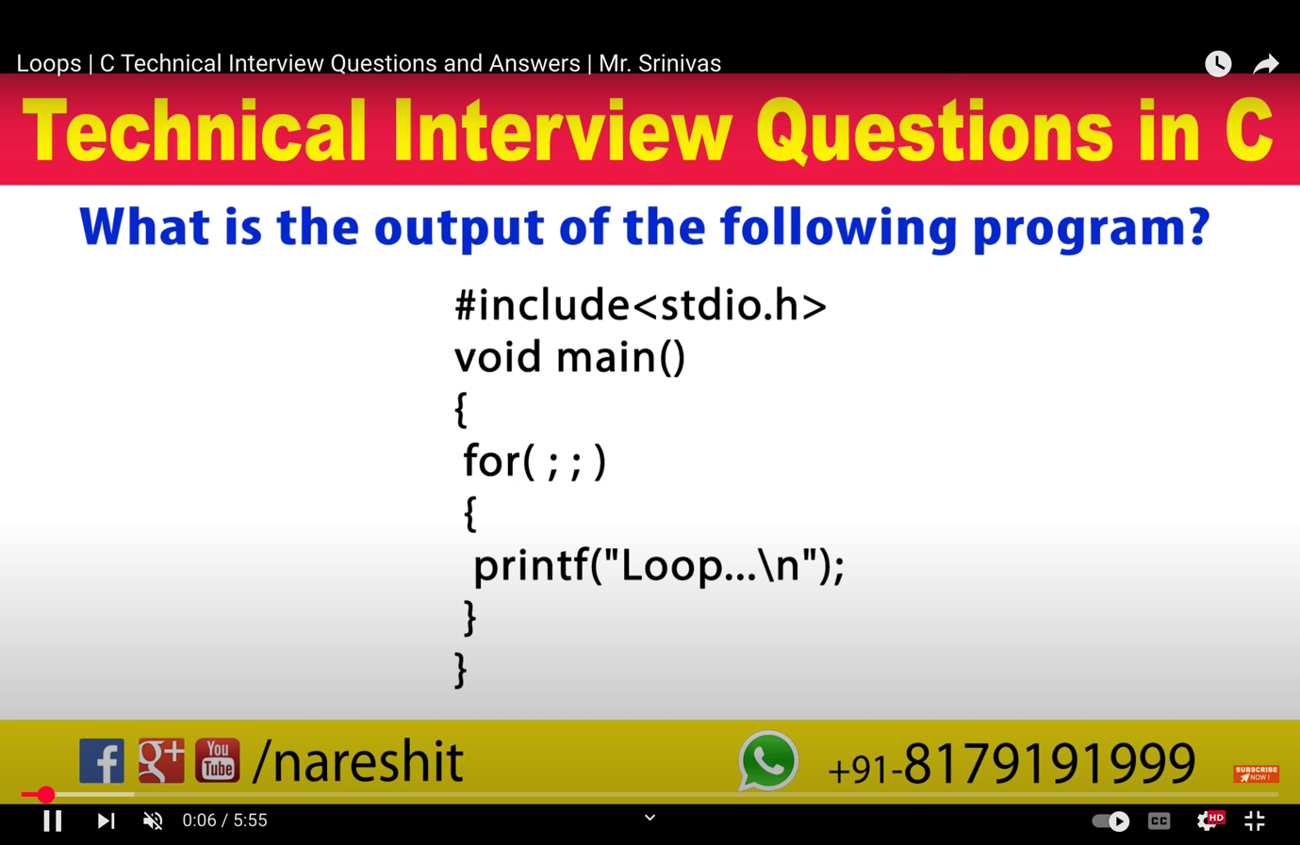

1. #include <stdio.h>

int main()

{

printf("geeks");

while (1) {

printf("geeks");

}return 0;

}

B..

#include <stdio.h>

int main()

{

while (printf("geeks"))

return 0;

}

C.. #include <stdio.h>

int main()

{

if (printf("geeks"))

switch (printf("for"))

while (printf("geeks"))

return 0;

}

D.. #include <stdio.h>

int main()

{

if (printf("geeks") != 5) {

} else

printf("geeksforgeeks");

return 0;

}

E. How many times will GeeksQuiz be printed

#include <stdio.h>

int main()

{

int i = 1024;

for (; i; i >>= 1)//shift 1 by right

printf("GeeksQuiz");

return 0;

}

Ans:- 11 times

f. How many times **GeeksQuiz** is printed

(The double backslashes (\\) are used in the **macro definition** to indicate **line continuation** in **C preprocessor directives**.

**Why Use \\ (Backslash)?**

• In C, preprocessor macros (#define) are usually **single-line**.

• If a macro definition needs to **span multiple lines**, we use a **backslash (\) at the end of each line** to continue it on the next line.

• The compiler treats the entire multi-line macro as a **single logical line**.

)

#include <stdio.h>

#define PRINT(i, limit) do \\

{ \\

if (i++ < limit) \\

{ \\

printf("GeeksQuiz\\n"); \\

continue; \\

} \\

}while(0);

int main()

{

int i = 0;

PRINT(i, 3);

return 0;

}

Ans-1 times

**Alternative Without Backslash (Not Recommended)**

Using macros without line continuation can make them hard to read:

#define PRINT(i, limit) do { if (i++ < limit) { printf("GeeksQuiz\n"); continue; } } while(0)

g.. #include <stdio.h>

int main() {

int i = 2;

switch (i) {

case 0:

printf("Geeks");

break;

case 1:

printf("Quiz");

break;

default:

printf("GeeksQuiz");

}

return 0;

}

h.. #include <stdio.h>

int main() {

int i = 3;

switch (i) {

case 1:

printf("Geeks");

break;

case 1+2:

printf("Quiz");

break;

default:

printf("GeeksQuiz");

}

return 0;

}

i.. #include <stdio.h>

int main()

{

int i = 1024;

for (; i; printf("%d",i >>1))

printf("GeeksQuiz%d\n ",i);

return 0;

}

j.. #include <stdio.h>

#define EVEN 0

#define ODD 1

int main() {

int i = 3;

switch (i % 2) {

case EVEN:

printf("Even");

break;

case ODD:

printf("Odd");

break;

default:

printf("Default");

}

return 0;

}

k.. #include *<stdio.h>*

int main() {

int i;

**if** (printf("0"))

i = 3;

**else**

i = 5;

printf("%d", i);

**return** 0;

}

L. #include *<stdio.h>*

int i;// Since i is defined globally, it is initialized with default value 0. The Else block is executed as the expression within if evaluates to FALSE. . Therefore, the else block gets executed.

int i;

int main() {

**if** (i) {

*// Do nothing*

} **else** {

printf("Else");

}

**return** 0;

}

M.. #include*<stdio.h>*

int main()

{

int n;

**for** (n = 9; n!=0; n--)

printf("n = %d", n--);

**return** 0;

}

N. #include *<stdio.h>*

int main()

{

int c = 5, no = 10;

**do** {

no /= c;

} **while**(c--);

printf ("%d**\\**n", no);

**return** 0;

}

o. # include *<stdio.h>*

int main()

{

int i = 0;

**for** (i=0; i<20; i++)

{

**switch**(i)

{

**case** 0:

i += 5;

**case** 1:

i += 2;

**case** 5:

i += 5;

**default**:

i += 4;

**break**;

}

printf("%d ", i);

}

**return** 0;

}

P. #include*<stdio.h>*

int main()

{

int i = 0;

**for** (printf("1st**\n**"); i < 2 && printf("2nd**\n**"); ++i && printf("3rd**\n**"))

{

printf("\***\n**");

}

**return** 0;

}

Ans: 1st  
2nd  
*  
3rd  
2nd  
*  
3rd

Q. #include *<stdio.h>*

int main()

{

int i;

**for** (i = 1; i != 10; i += 2)

printf(" GeeksQuiz ");

**return** 0;

}

Ans:- GeeksQuiz GeeksQuiz GeeksQuiz .... infinite times

R. char inchar = 'A';

**switch** (inchar)

{

**case** 'A' :

printf ("choice A **\n**") ;

**case** 'B' :

printf ("choice B ") ;

**case** 'C' :

**case** 'D' :

**case** 'E' :

**default**:

printf ("No Choice") ;

}

Ans: Choice A  
Choice B No choice

S. #include *<stdio.h>*

int main()

{

int i = 3;

**switch**(i)

{

printf("Outside ");

**case** 1: printf("Geeks");

**break**;

**case** 2: printf("Quiz");

**break**;

defau1t: printf("GeeksQuiz");

}

**return** 0;

}

Ans:- Nothing gets printed

T. In the following program, X represents the Data Type of the variable check.

#include *<stdio.h>*

int main()

{

X check. ;// A switch expression can be int, char and enum. A float variable/expression cannot be used inside switch

**switch** (check)

{

*// Some case labels*

}

**return** 0;

}

Ans:- float

U. #include *<stdio.h>*

int main()

{

char check = 'a';

**switch** (check)

{

**case** 'a' || 1: printf("Geeks ");// complie time error syntax is wrong  
 ‘a’||1 return 1 and ‘b’||2 is also return 1 , so we get error duplicate value

**case** 'b' || 2: printf("Quiz ");

**break**;

**default**: printf("GeeksQuiz");

}

**return** 0;

}

Ans:= Compile-time error

v. #include *<stdio.h>*

int main()

{

int check = 20, arr[] = {10, 20, 30};

**switch** (check)

{

**case** arr[0]: printf("Geeks ");

**case** arr[1]: printf("Quiz ");

**case** arr[2]: printf("GeeksQuiz");

}

**return** 0;

}

Ans: Compile-time error

w. How many times GeeksQuiz is printed

#include*<stdio.h>*

int main()

{

int i = -5;

**while** (i <= 5)

{

**if** (i >= 0)

**break**;

**else**

{

i++;

**continue**;

}

printf("GeeksQuiz");

}

**return** 0;

}

Ans= 0 times

x.

#include *<stdio.h>*

int main()

{

int i = 3;

**while** (i--)

{

int i = 100;

i--;

printf("%d ", i);

}

**return** 0;

}

Ans=99 99 99

y. #include *<stdio.h>*

int main()

{

int x = 3;

**if** (x == 2); x = 0;

**if** (x == 3) x++;

**else** x += 2;

printf("x = %d", x);

**return** 0;

}

Ans:-   
x = 2

z. #include*<stdio.h>*

int main()

{

int a = 5;

**switch**(a)

{

**default**:

a = 4;

**case** 6:

a--;

**case** 5:

a = a+1;

**case** 1:

a = a-1;

}

printf("%d **\\**n", a);

**return** 0;

}

Ans-5. # start from matching

1. #include *<stdio.h>*

int main()

{

int i;

**for** ( i=0; i<5; i++ )

{

int i = 10;

printf ( "%d ", i );

i++;

}

**return** 0;

}

Ans: 10 10 10 10 10

2. #include <stdio.h>

int main()

{

int i = 3;

switch(i)

{

case 1: printf("Geeks");

break;

case 2: printf("Quiz");

break;

default: printf("GeeksQuiz");

printf("Outside ");

}

return 0;

}

3. #include <stdio.h>

int main() {

#include <stdio.h>

{

int i = 2;

printf("%d ", i);

//return 0;

}

Segmentation fault

J’